**Tables Used are –**

1. **Employee_Info:** Contains employee information.

|  |  |  |  |  |  |
| --- | --- | --- | --- | --- | --- |
| **Column Name** | **Data Type** | | **Constraint** | | **Description** |
| Employee_Id | Number (5) | | Primary key | | Employee Identification No |
| Employee_Name | Varchar2 (10) | | Not null | | Employee name |
| DoJ | Date | |  | | Employee Date of joining |
| Employee_Address | Varchar2 (15) | |  | | employee address |
| Phone_Num | Number (10) | |  | | Employee_phone No |
| Salary | Number (10) | |  | | Salary earned by employee |
|  | |  | |  | | |

1. **Department_info:** Contains details of Department.

|  |  |  |  |
| --- | --- | --- | --- |
| **Column Name** | **Data Type** | **Constraint** | **Description** |
| Depart_Id | Number (5) | Primary key | Department Identification No |
| Department_Name | Varchar2 (10) | Not null | Department Name |
| Company_Address | Varchar2 (20) |  | Company Address |
| Employee_id | Number (5) | Foreign key | Employee Identification No |

**Questions**

1. Create tables named employee_info and department_info with the structure as provided above. Add employee and department details (min 5 rows to be inserted). Write a query to Join both the tables and display information in both the tables. [Employee_Info, Department_info] [3 marks]

**Sample output:**

Employee_id Employee_Name DoJ Employee_address Phone_Num Salary Dept_id Dept_name Company_Address Employee_id

-------------- -------------- --- ------ -------------------- ------------- -------- -------- ------------- -------

110 Amit 12/12/10 E-7 778888888 45000 D111 HR H-7 110

ANS:

**TABLE CREATION:**

create table Employee_Info

(

Employee_Id number(5) constraint emp_id_p_key primary key,

Employee_Name varchar2(10),

DOJ Date,

Employee_Address varchar2(15),

Phone_Num number(10),

Salary number(10)

);

**INSERT FOR THE TABLE:**

Insert into Employee_Info values(101, 'Amit',TO_DATE('2010/12/12','yyyy/mm/dd'),'E_Address_1', 123456789, 54678);

insert into Employee_Info values(102, 'Tejas',TO_DATE('2010/05/12','yyyy/mm/dd'),'E_Address_2', 12568792, 12568);

insert into Employee_Info values(103, 'Ram',TO_DATE('2010/05/06','yyyy/mm/dd'),'E_Address_3', 784567892, 17868);

insert into Employee_Info values(104, 'Tim',TO_DATE('2010/03/05','yyyy/mm/dd'),'E_Address_4', 124566789, 1000);

insert into Employee_Info values(105, 'Jim',TO_DATE('2010/02/08','yyyy/mm/dd'),'E_Address_5', 1235789, 78000);

insert into Employee_Info values(106, 'Rim',TO_DATE('2010/06/08','yyyy/mm/dd'),'E_Address_6', 12375789, 74500);

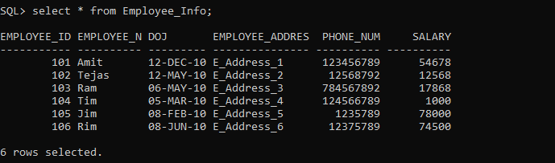

**TABLE CREATION:**

create table Department_info

(

Depart_Id number(5) constraint dept_id_p_key primary key,

Department_Name varchar2(10),

Company_Address varchar2(20),

Employee_id number(5)

);

**INSERT FOR THE TABLE:**

insert into Department_info values(104, 'D101', 'C_Address_1',102);

insert into Department_info values(145, 'D102', 'C_Address_2',101);

insert into Department_info values(103, 'D103', 'C_Address_3',104);

insert into Department_info values(125, 'D104', 'C_Address_4',105);

insert into Department_info values(128, 'D105', 'C_Address_5',103);

insert into Department_info values(129, 'D106', 'C_Address_6',108);

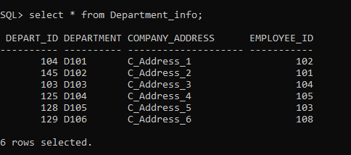

select e.Employee_Id, e.Employee_Name, e.DOJ, e.Employee_Address, e.Phone_Num, e.Salary, d.Depart_Id, d.Department_Name, d.Company_Address, d.Employee_id from Employee_Info e full outer join Department_info d on e.Employee_Id = d.Employee_Id;

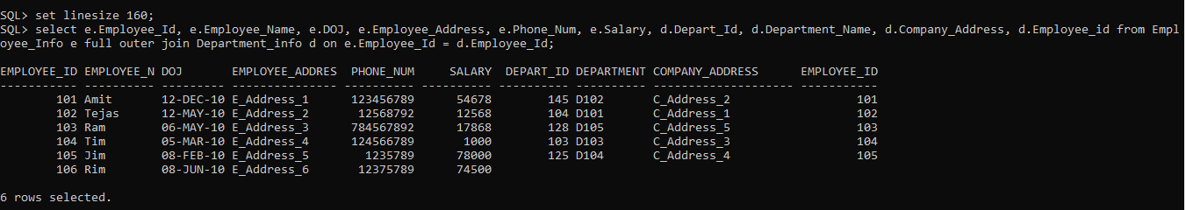

Added 1 more column in right table to see the difference between the outer and left join

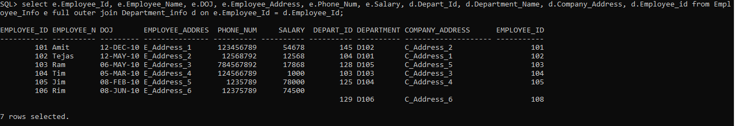

Both are same output

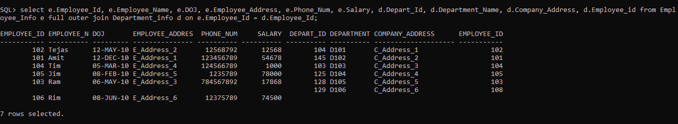

1. Write a query to display all the records from the left table and from right table only the matched records (Left table: Employee_info and right table: Department_info): (4 marks)

**Sample output:**

Employee_id Employee_Name DoJ Employee_address Dept_id Dept_name

--------------- ------------------ ------- -------------------- ----------- ------------

112 Raghu 10/12/18 J-7 ….. F101 Finance

ANS:

select e.Employee_Id, e.Employee_Name, e.DOJ, e.Employee_Address, e.Phone_Num, e.Salary, d.Depart_Id, d.Department_Name, d.Company_Address, d.Employee_id from Employee_Info e left join Department_info d on e.Employee_Id = d.Employee_Id;

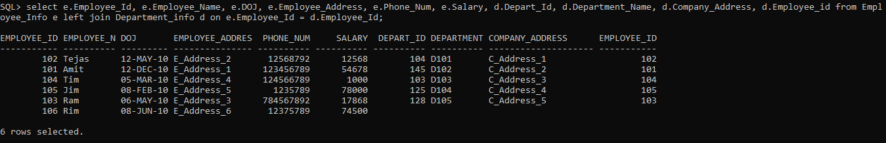

1. Write a query to return all records/rows from the right table and from left table returns only matched records (Left table: Employee_info and right table: Department_info): (4 marks)

**Sample output:**

Dept_id Dept_name Company_Address Employee_id Employee_name

--------- ------------ --------------------- -------------- --------------

H111 HR H-123,JP nagar 113 Stephen

ANS:

select e.Employee_Id, e.Employee_Name, e.DOJ, e.Employee_Address, e.Phone_Num, e.Salary, d.Depart_Id, d.Department_Name, d.Company_Address, d.Employee_id from Employee_Info e right join Department_info d on e.Employee_Id = d.Employee_Id;

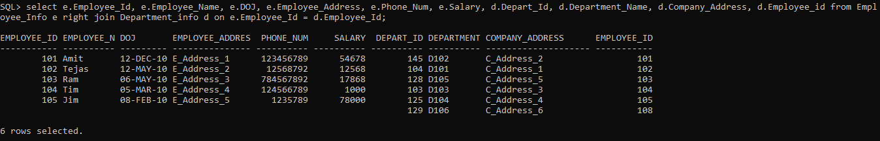

1. Normalization helps to reduce redundancy and complexity. Justify the statement explaining 1NF,2NF,3NF with examples. (10 marks)

ANS:

The Database is the most important part of the project and entire structure has to be handled systematically and the data as well. As the data is perfect or handled properly for any system then it is said that the 70% of the solutions get resolved. For storing the data, databases have to be chosen then the data has to be organized in the database.

So, the entire data process will be organized using the different DB methods. One of them is normalization. Normalization is process through which the data can be organized to avoid or reduce the data redundancy and anomalies of all sorts. It aids in the division of large database tables into smaller ones and the establishment of relationships between them. It has the ability to delete redundant data and is simple to incorporate, manipulate and delete. There are 3 types of anomalies found when we don’t follow the normalization and they are insert, delete, update anomalies.

Six different forms:

* 1NF
* 2NF
* 3NF
* BCNF
* 4NF
* 5NF

**1NF** – First Normal form: According to the first rule, the data in any column must have an atomic value (single value) only, i.e., the column attribute cannot hold multiple values in any table.

|  |  |  |
| --- | --- | --- |
| **FirstName** | **LastName** | **Knowledge** |
| John | Wick | C++, JAVA |
| Sam | Curran | Python |
| Huge | Philips | JAVA, PYTHON |

The above e.g., is not 1NF as the knowledge column has more than one value. So, we need to convert it to 1NF.

|  |  |  |
| --- | --- | --- |
| **FirstName** | **LastName** | **Knowledge** |
| John | Wick | C++ |
| John | Wick | JAVA |
| Sam | Curran | Python |
| Huge | Philips | JAVA |
| Huge | Philips | PYTHON |

**2NF** – To perform 2NF the table has to be in 1NF (First Normal form). The non-prime attribute of the table should not be dependent on the subset of any candidate key of the table. The non-prime attribute is defined as the column attribute which are not part of the candidate key.

|  |  |  |
| --- | --- | --- |
| **StudentID** | **StudentName** | **ProjectName** |
| S01 | John | Smart City |
| S10 | Jacob | R&D |
| S03 | Alan | Machine connectivity |
| S08 | Alex | R&D |

ProjectName is a non-prime attribute as it completely dependent on the STUDENTID as the student will have their project assigned to them and they are totally related or dependent. This has to be converted to 2NF. It is already in 1NF as there are no multiple values for any columns.

The below table will be created for the 2NF

|  |  |  |
| --- | --- | --- |
| **StudentID** | **StudentName** | **ProjectID** |
| S01 | John | P05 |
| S10 | Jacob | P04 |
| S03 | Alan | P12 |
| S08 | Alex | P04 |

|  |  |
| --- | --- |
| **ProjectID** | ProjectName |
| P05 | Smart City |
| P04 | R&D |
| P12 | Machine Connectivity |

**3NF** – To implement 3NF the table has to be in 2NF, else we need to convert it to 2NF first and then proceed. It shouldn’t hold the transitive functional dependency. Transitive dependency can be explained like If there are 3 variable a,b,c and a is dependent on b (also called as functional dependency), b is dependent on c so the a will be dependent on c. We should work on to remove these transitive dependencies.

|  |  |  |  |
| --- | --- | --- | --- |
| U_ID | U_Name | U_Ac | Bank |
| 111 | Sejal | 20156 | BOI |
| 256 | Harry | 12560 | SBI |
| 335 | Don | 12480 | SBI |
| 258 | Linn | 12459 | J&K |
| 489 | Sam | 56879 | KMB |

U_Name, U_Ac, Bank all are functionally dependent on U_ID.

Candidate key for the above table – U_ID, U_Name

|  |  |  |  |  |
| --- | --- | --- | --- | --- |
| U_ID | U_Name | U_Ac | Bank_Code | Bank |
| 111 | Sejal | 20156 | BOI01 | BOI |
| 256 | Harry | 12560 | SBI01 | SBI |
| 335 | Don | 12480 | SBI01 | SBI |
| 258 | Linn | 12459 | J&K01 | J&K |
| 489 | Sam | 56879 | KMB01 | KMB |

The above table is in 1NF and 2NF but there is a transitive dependency of Bank_Code on Bank. To fix this we will create a separate table for the Bank.

|  |  |  |  |
| --- | --- | --- | --- |
| U_ID | U_Name | U_Ac | Bank_Code |
| 111 | Sejal | 20156 | BOI01 |
| 256 | Harry | 12560 | SBI01 |
| 335 | Don | 12480 | SBI01 |
| 258 | Linn | 12459 | J&K01 |
| 489 | Sam | 56879 | KMB01 |

|  |  |
| --- | --- |
| Bank_Code | Bank |
| BOI01 | BOI |
| SBI01 | SBI |
| J&K01 | J&K |
| KMB01 | KMB |

There are 3 more rules for the normalization which are BCNF, 4NF and 5NF. And all these will help to reduce the data redundancy and anomalies like insert, delete and update.

1. Create tables Course_info,student_info using the table structure as given below and details in course_info,student_info tables (min 5 rows to be inserted) and perform the following operations:

**.**

**Courses_info:** Contains the details of various courses.

|  |  |  |  |
| --- | --- | --- | --- |
| **Column Name** | **Data Type** | **Constraint** | **Description** |
| Course_Id | Number (5) | Primary key | Course Identification No |
| Course_Name | Varchar2 (20) | Not null | Course Name |
| Course_details | Varchar2 (30) |  | Course Description |
|  |  |  |  |

Student_Info

|  |  |  |  |
| --- | --- | --- | --- |
| **Column Name** | **Data Type** | **Constraint** | **Description** |
| Rollno | Number (4) |  | Student Rollno |
| Marks | Number | Not null | Marks scored by student |
| Student_address | Number (5) |  | Student address |
| Course_Id | Number (5) | Foreign key | Course Identification No |
| Student_name | Varchar(15) |  | Student’s name |

1. Combine the tables and do not display the duplicates ( 2 marks.)

Sample output:

Course-id Coursename Course-details Roll no Marks Student_Name Students_Address

----------- ------------- ------------------ ------- ------ ------------------- ------------------

M123 Masters MCA 113 85 Anita Rao J-56

ANS: Assumpiton: Combine will help us to merge to tables where both the table should have same schema followed. Combining a table is using UNION concept in DBs. To achieve the solution, we have assumed the Student_Info as the table 1 with schema as Rollno, Marks, Student_address, Course_Id, Student_name and the next table as Student_Info1 with the same schema. So that we can combine both the tables.

**QUERY:**

**TABLE CREATION:**

create table Student_Info

(

Rollno number(4),

Marks number(3),

Student_address varchar(10),

Course_Id number(5),

Student_name varchar(15)

);

**INSERT INTO TABLE:**

insert into Student_Info values (0001,89, 'ST_Addr_1', 11, 'Linn');

insert into Student_Info values (0002,58, 'ST_Addr_2', 15, 'Tim');

insert into Student_Info values (0003,67, 'ST_Addr_3', 16, 'Jim');

insert into Student_Info values (0004,96, 'ST_Addr_4', 18, 'SRK');

insert into Student_Info values (0005,92, 'ST_Addr_5', 22, 'Jack');

insert into Student_Info values (0006,79, 'ST_Addr_6', 08, 'Smith');

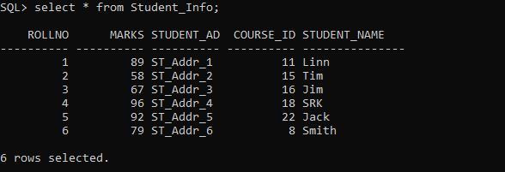

**TABLE CREATION:**

create table Student_Info1

(

Rollno number(4),

Marks number(3),

Student_address varchar(10),

Course_Id number(5),

Student_name varchar(15)

);

**INSERT INTO TABLE:**

insert into Student_Info1 values (0002,58, 'ST_Addr_2', 15, 'Tim');

insert into Student_Info1 values (0007,97, 'ST_Addr_7', 35, 'Meril');

insert into Student_Info1 values (0008,89, 'ST_Addr_8', 42, 'Domm');

insert into Student_Info1 values (0005,92, 'ST_Addr_5', 22, 'Jack');

insert into Student_Info1 values (0009,64, 'ST_Addr_9', 58, 'Rahul');

insert into Student_Info1 values (0010,64, 'ST_Addr_10', 02, 'Steve');

insert into Student_Info1 values (0003,67, 'ST_Addr_3', 16, 'Jim');

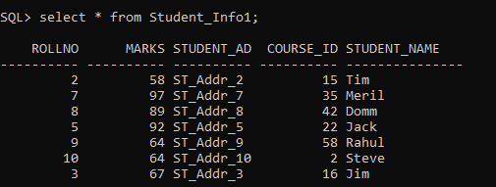

**COMBINING QUERY:**

select * from Student_Info union select * from Student_Info1;

**OUTPUT:**

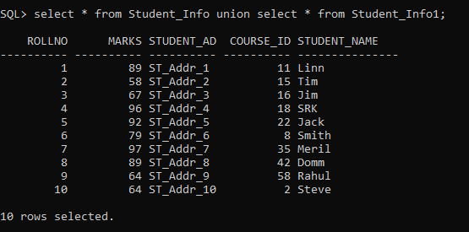

1. Combine both tables and Display all students enrolled for Course_details (MBA) and have scored marks above 85 (3 marks.)

Sample output:

Rollno Student_Name Student_address Course_Id Marks Course_Name Course_details

------ ----------------- -------------------- ----------- ------- ---------------- -----------------

114 Bina Verma B-7, Jayanagar MB1 89 MBA Masters

118 Nimita Singh V-7 Noida MB1 87 MBA Masters

ANS:

**QUERY:**

select * from Student_Info where Marks > 85 union select * from Student_Info1 where Marks > 85;

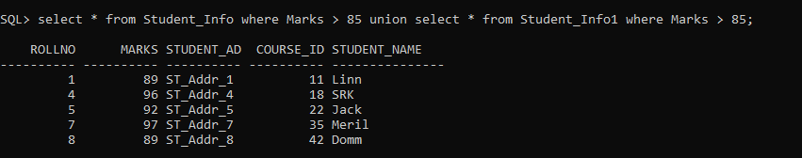

Above query will return without the duplicate keys and where conditions which is the actual output as per the ques.

But if we want to get the entire data i.e. repetitive data as well then use the below command

select * from Student_Info where Marks > 85 union all select * from Student_Info1 where Marks > 85;

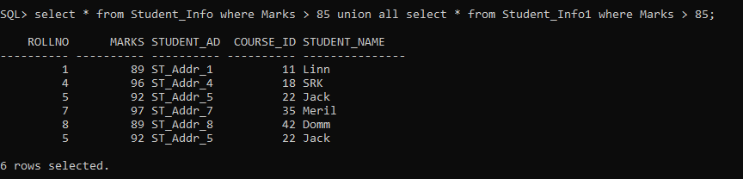

Also, if we want to have the Course_Name in the schema and while performing a query then below code and new table can be used. Course_Name has been taken as MBA as values as respect to the sample output given in the ques considered.

**TABLE CREATION:**

create table Student_Info2

(

Rollno number(4),

Marks number(3),

Student_address varchar(10),

Course_Id number(5),

Course_details varchar(30),

Course_Name Varchar2 (20),

Student_name varchar(15)

);

**INSERT INTO TABLE:**

insert into Student_Info2 values (0001,89, 'ST_Addr_1', 11, 'Eng', 'BTECH', 'Linn');

insert into Student_Info2 values (0002,58, 'ST_Addr_2', 15, 'Arts', 'MBA', 'Meril');

insert into Student_Info2 values (0003,67, 'ST_Addr_3', 16, 'BA Course 1', 'MBA', 'Domm');

insert into Student_Info2 values (0004,96, 'ST_Addr_4', 18, 'BA Course 2', 'MBA', 'Jack');

insert into Student_Info2 values (0005,92, 'ST_Addr_5', 22, 'BA Course 3', 'MBA', 'Steve');

insert into Student_Info2 values (0006,79, 'ST_Addr_6', 08, 'Arts B Course 1', 'BA', 'Smith');

**TABLE CREATION:**

create table Student_Info3

(

Rollno number(4),

Marks number(3),

Student_address varchar(10),

Course_Id number(5),

Course_details varchar(30),

Course_Name Varchar2 (20),

Student_name varchar(15)

);

**INSERT INTO TABLE:**

insert into Student_Info3 values (0002,58, 'ST_Addr_2', 15, 'Arts', 'MBA', 'Meril');

insert into Student_Info3 values (0007,97, 'ST_Addr_7', 38, 'Arts', 'MBA', 'Tim');

insert into Student_Info3 values (0008,89, 'ST_Addr_8', 26, 'Arts', 'MBA', 'Jim');

insert into Student_Info3 values (0005,92, 'ST_Addr_5', 22, 'BA Course 3', 'MBA', 'Steve');

insert into Student_Info3 values (0009,64, 'ST_Addr_9', 19, 'Arts', 'MBA', 'Rahul');

insert into Student_Info3 values (0010,82, 'ST_Addr_10', 68, 'Commerce', 'BCOM', 'Don');

insert into Student_Info3 values (0003,67, 'ST_Addr_3', 16, 'BA Course 1', 'MBA', 'John');

To Display all the data except duplicate:

**COMBINING QUERY:**

select * from Student_Info2 union select * from Student_Info3;

**OUTPUT:**

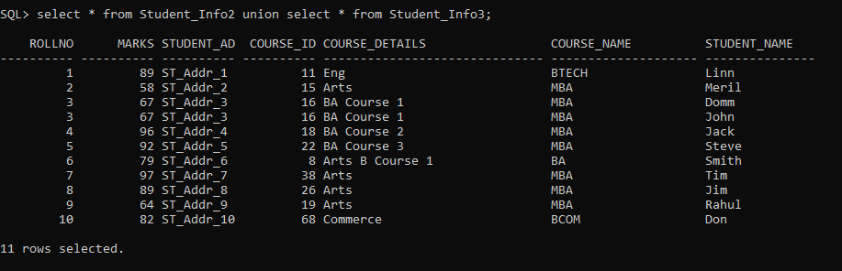

To Display the records based on the condition added i.e. MBA as Course_Name

**QUERY:**

select * from Student_Info2 where Marks > 85 and Course_Name = 'MBA' union select * from Student_Info3 where Marks > 85 and Course_Name = 'MBA';

**OUTPUT:**

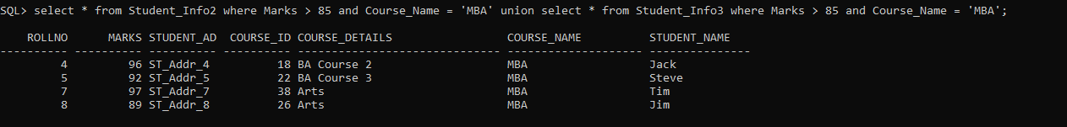

1. Write a procedure to find maximum of 2 numbers. (4 marks)

OR

Write the difference between procedures and functions with two examples

Finding the maximum of the two numbers:

Using the below code to show the output of PROCEDURE else it won’t show:

set serveroutput on;

WRINTING PROCEDURE TO FIND THE MAXIMUM OF THE 2 NUMBERS

CODE:

DECLARE

a1 number;

b1 number;

c1 number;

PROCEDURE findMax(x1 IN number, y1 IN number, z OUT number) IS

BEGIN

IF x1>y1 THEN

z:=x1;

Else

z:=y1;

END IF;

END;

BEGIN

a1 := 102;

b1 := 68;

findMax(a1,b1,c1);

dbms_output.put_line('Maximum of the two given number is :' ||c1);

END;

/

**OUTPUT:**

